TESTING SMTP SERVER

Submitted By

Project Leader: Talha Munir Saeed
Project Leader Roll Number: 22K-4465

Department of Computer Science
National University of Computer & Emerging Sciences

1. Motivation
The motivation behind developing a custom SMTP server with storage capabilities stems from the need to understand email protocols at a fundamental level while creating a practical solution for email management and storage. Traditional SMTP servers primarily focus on sending emails, but our implementation addresses the gap by providing comprehensive email handling, including reception, storage, and management functionality. This project demonstrates the practical application of network protocols and database management in creating a full-featured email system.

2. Overview
Our project presents a comprehensive email client application that revolutionizes email management by combining user-friendly interface design with powerful backend functionality. This system addresses the limitations of traditional email solutions by providing a unified platform for both sending and receiving emails while maintaining complete control over data storage and organization with different providers.
The application serves as a bridge between standard email protocols (SMTP and IMAP) and modern user expectations for email management. Users can seamlessly compose, send, receive, and organize emails while benefiting from advanced features such as code syntax highlighting, intelligent attachment handling, and persistent email history storage. The system supports multiple email providers including Gmail, Yahoo, and Outlook, making it versatile for various user needs.
At its core, the project demonstrates the practical implementation of network protocols, database management, and graphical user interface development. It provides students and developers with insights into how popular email clients work while offering the flexibility to customize and extend functionality as needed.

2.1 Significance of the Project
The email client implementation project provides hands-on experience with network protocols, GUI development, and database management. It challenges students to understand email communication at both protocol and application levels, combining SMTP/IMAP protocols with modern user interface design.The project's significance is amplified by its unique features like Intelligent code detection, Advanced email management, Multi-provider support, Real-time email processing
The project has practical applications in enterprise environments requiring custom email handling, educational value in demonstrating protocol implementation, and serves as a foundation for understanding modern email client architecture. Its focus on code file handling makes it particularly relevant for developer communities and academic environments.

2.2 Description of the Project
Our project implements a complete email client application with both graphical user interface (GUI) and backend functionality for handling email operations. Unlike traditional SMTP servers that only handle sending we also went along and implemented IMAP for receiving, our system provides a comprehensive solution for:
- Email Sending: Using SMTP protocol with features like HTML support, attachments, and syntax highlighting
- Email Receiving: Using IMAP protocol for fetching and organizing emails
- Email Storage: MySQL database integration for persistent storage of sent and received emails
- User Interface: Tkinter-based GUI for easy interaction with the email system
The project addresses the need for a custom email client that provides full control over email management while understanding the underlying protocols. It demonstrates practical implementation of network protocols, database management, and GUI development.

2.3 Background of the Project
A review of background material that we found
- RFC 5321: Simple Mail Transfer Protocol [1]
- RFC 5322: Internet Message Format [2]
- RFC 3501: Internet Message Access Protocol - Version 4rev1 [3]
- SMTP specification documentation
- IMAP protocol specifications
- Python socket programming documentation [4]
- Python threading and queue documentation [5]
- MySQL connector/Python documentation [6]
- Tkinter GUI programming guide [7]
- Email attachment handling best practices [8]
- SSL/TLS encryption standards for email protocols
Note: While online video tutorials were referenced during development for practical implementation guidance, this report focuses on official documentation and technical standards as primary sources.

2.4 Project Category
This project falls under the Research-based Product category as it involves:
- Research Component: Exploration of email protocol implementation, studying RFC standards (SMTP, IMAP), and investigating optimal architectures for email client design
- Product Component: Development of a functional email client application that can be used by real users for practical email management
While the project creates a usable product (email client), its primary value lies in the research aspects:
- Understanding and implementing email protocols from specifications
- Developing efficient asynchronous processing techniques
- Creating intelligent file detection algorithms
- Designing optimized database schema for email storage
The project demonstrates academic research in network protocols while producing a practical software solution, making it a research-oriented product rather than purely commercial software development.

3. Features / Scope / Modules
This project implements core components of an email client by directly interacting with SMTP and IMAP protocols, offering both practical functionality and protocol-level insight. It stands out from standard email clients by emphasizing custom protocol-level communication and educational clarity. The following are the key features and modules:

- Multi-threaded Connection Handling
Concurrent handling of multiple SMTP connections using Python's threading, allowing the server to process multiple email submissions simultaneously without blocking.

- IMAP Email Reception System
Comprehensive IMAP4-SSL implementation for secure email retrieval from mail servers. Supports connection handling, mailbox selection, email searching (including unread messages), and mail fetching with RFC822 compliance.

- Email Storage and Database Integration
Persistent storage of both sent and received emails in MySQL database with proper schema design. Includes separate handling for email metadata (sender, recipients, subject, date) and content (body, HTML content, attachments).

- Intelligent Attachment Management
Advanced attachment processing with automatic file type detection, filename decoding for international characters, duplicate file handling, and organized storage structure with email-specific folders.

- Database Management System
MySQL database integration with a custom DatabaseManager class that handles all database operations. Includes comprehensive table structures for users, emails, attachments, and recipients with foreign key relationships.

- Email Lifecycle Tracking
Complete tracking of sent and received emails with timestamps, differentiation between sent/received status, and proper metadata storage including sender, recipients, subject, and body content.

- File Storage System
Organized file system for storing attachment files with customized folder structure per email, automatic duplicate file handling, and path management for easy retrieval of stored files.

- Tkinter GUI Email Client
User-friendly graphical interface with login authentication, email composition window with rich formatting options, inbox management, and email history viewer. Supports multiple email providers (Gmail, Yahoo, Outlook).

- Multi-threaded Email Processing
Asynchronous email operations using Python threading and queue system for sending and receiving emails without blocking the user interface. Producer-consumer pattern for handling background tasks efficiently.

- Code Snippet Manager
Advanced code sharing functionality with language detection, syntax highlighting, and indentation preservation. Supports 25+ programming languages with proper MIME type handling and attachment capabilities.

- Email History Management
Comprehensive email tracking system with database storage, filtering by sent/received status, and detailed email viewer with attachment management. Persistent storage across sessions.

- Email Interaction
This feature enables users to interact with received emails in a meaningful way. After retrieving messages like Marking emails as read, Printing full email content, Forwarding, Replying.

4. Diagrammatic Representation of the Overall System

System Architecture

The architecture type is a Layered Client-Server Architecture with Producer-Consumer Threading Model.
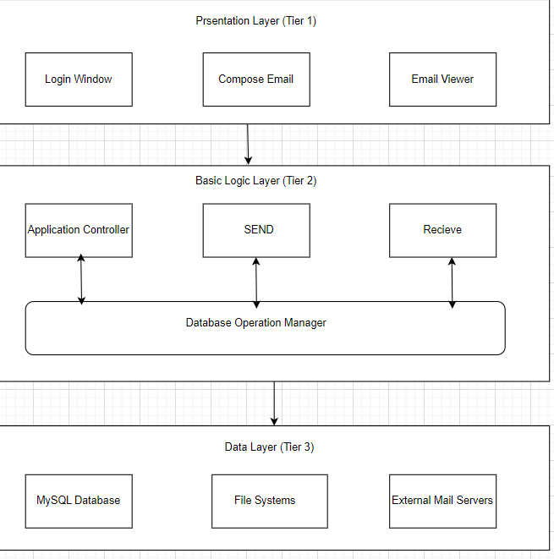
Fig 1. Project Architecture
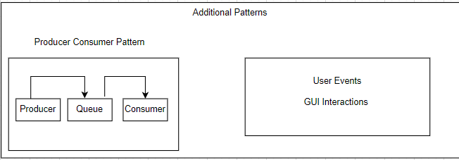
Fig 2. Additional Patterns
Fig 1-2 show the system architecture some features include:
- GUI Layer: Tkinter application interface
- Backend Services: SMTP sending and IMAP receiving modules
- Database Layer: MySQL storage with DatabaseManager
- File System: Organized attachment storage
- Producer Consumer: For handling background tasks efficiently
- Network Protocols: SSL/TLS encryption for secure communication

4.1 Database Schema:
The database schema shows different entities with different attributes all of which are related to each other. Some entities include

- users table: Stores user credentials, display names, and provider information
- emails table: Stores email metadata (subject, sender, recipients, date) with user relationship
- attachments table: Stores file information with email relationship and code detection flag
- recipients table: Tracks email recipients with type (to, cc, bcc) and email relationship
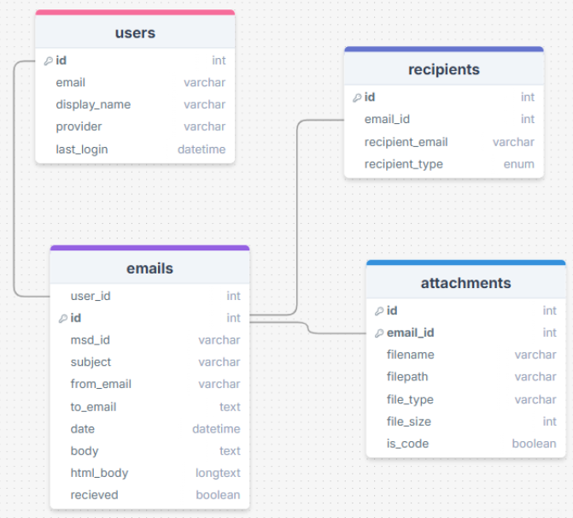
Fig 3. E-R Diagram

4.2 SystemFlow Diagram:
Complete email client workflow showing login process, email composition/sending via SMTP, email reception via IMAP, and storage in MySQL database.

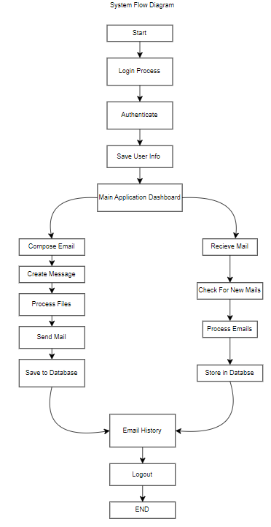
Fig 4. Workflow diagram

5. Testing Approach and Methodology

5.1 Initial Testing Strategy
Initially, we planned to implement automated testing using Selenium. However, during the implementation phase, we encountered significant challenges that made Selenium unsuitable for our project.
Challenges with Selenium:
- Selenium is primarily designed for web-based applications and browser automation
- Our project uses Tkinter, a built-in Python GUI library that creates desktop applications
- Selenium cannot interact with native desktop GUI elements created by Tkinter
- The framework lacks support for non-web UI components such as Tkinter widgets (buttons, entry fields, frames, etc.)
- Attempts to integrate Selenium resulted in compatibility issues and inability to locate UI elements

5.2 Transition to unittest Framework
After evaluating our testing requirements and the limitations encountered with Selenium, we adopted Python's built-in unittest framework for our testing strategy.

6. Advantages of using unittest

Some features and instances of unittest such as:
- Native Python Integration
- Perfect for Backend Logic Testing
- Comprehensive Testing Capabilities
- Test Organization and Structure
- Detailed Reporting

Maintainability and Scalability

Provides us help with those issues and situations where selenium was lacking which mostly is the UI part of things.

7. Key Testing Points in Our Project

7.1 Core Functionality Testing
Email Sending Operations
- Sending emails with valid SMTP credentials
- Sending emails to single and multiple recipients
- Email composition with subject and body content
- HTML and plain text email format support
Email Receiving Operations
- Connecting to IMAP server for email retrieval
- Fetching emails from inbox
- Retrieving unread and read emails
- Email synchronization and updates
- Handling different mailbox folders
Attachment Handling
- Sending emails with single attachments
- Sending emails with multiple attachments
- Supporting various file types (documents, images, code files, etc.)
- Downloading attachments from received emails
- Attachment size validation
- File encoding and decoding operations
Reply and Forward Operations
- Replying to received emails
- Reply with original message thread
- Forwarding emails to other recipients
- Preserving email headers and metadata
- Maintaining email conversation chains
Database Operations
- Storing sent emails in database
- Storing received emails in database
- Retrieving stored emails with filters
- Updating email status (read/unread, flagged, etc.)

Print Functionality
- Printing email content
- Formatting emails for print output
- Handling special characters in print

7.2 Authentication and Connection Testing
Email Provider Authentication
- Gmail authentication with app password
- Outlook authentication with app password (Not Received)
- Yahoo authentication with app password (Not Working Region Issue)
- Handling invalid credentials
- Testing connection timeout scenarios
SMTP/IMAP Connection Management
- Establishing SMTP connection for sending
- Establishing IMAP connection for receiving
- Connection retry mechanism
- Handling connection failures
- Secure SSL/TLS connection verification

7.3 Data Validation Testing
Input Validation
- Validating email address formats
- Testing empty recipient fields
- Validating subject and body content
- Testing special characters in email content
- Validating attachment file paths
Email Content Validation
- Email header validation
- MIME type validation for attachments
- Character encoding validation
- Email size limit validation
- Malformed email handling
Database Data Integrity
- Email metadata storage verification
- Attachment reference integrity
- Data persistence validation
- Duplicate email prevention

7.4 Error Handling and Edge Cases
Network and Connection Errors
- Handling network disconnections
- SMTP server unavailable scenarios
- IMAP server timeout handling
- Authentication failure handling
File and Attachment Errors
- Missing attachment file handling
- Corrupted attachment handling
- Large file size errors
- Unsupported file type handling
- Insufficient storage space scenarios
Email Processing Errors
- Malformed email address handling
- Empty email body handling
- Invalid MIME encoding
- Special character encoding issues
- Email parsing errors

7.5 Security Testing
Credential Security
- App password validation
- Secure storage of credentials
- Prevention of credential exposure in logs
- SSL/TLS encryption verification
Data Privacy
- Email content encryption in database
- Secure attachment storage
- Access control for stored emails
- Prevention of unauthorized email access

8. Test Case Summary

8.1 Test Coverage Overview
Our comprehensive test suite consists of 116 test cases covering various aspects of the SMTP email server system. The test cases are distributed across different functional areas and severity levels to ensure thorough validation of the application.
Test Distribution by Type:
- Unit Tests: Testing individual functions and methods
- Integration Tests: Testing interaction between email protocols and database
- Functional Tests: Testing complete email workflows (send, receive, reply, forward)
- Negative Tests: Testing error handling and invalid inputs
Test Distribution by Module:
- Email Sending Module (SMTP)
- Email Receiving Module (IMAP)
- Attachment Handling Module
- Database Operations Module
- Reply and Forward Module
- Print Functionality Module
- Authentication Module

8.2 Test Case Details
This section contains the comprehensive table with all test cases including Test Case ID, Input Parameters, Expected Output, Severity, Test Type,Category and Success.

TC ID | Test Case Name | Category | Input Parameters | Expected Output | Severity | Test Type | Status
TC-01 | Valid Email Formats | Email Validation | Valid email patterns | All emails match regex | High | Positive | ✓ PASS
TC-02 | Invalid Email Formats | Email Validation | Invalid email patterns | All emails rejected | High | Negative | ✓ PASS
TC-03 | SQL Injection Protection | Email Validation | Malicious SQL inputs | All inputs rejected | Critical | Security | ✓ PASS
TC-04 | Email with Plus Sign | Email Validation | user+tag@gmail.com | Matches regex (Gmail alias) | Medium | Positive | ✓ PASS
TC-05 | Email with Multiple Dots | Email Validation | first.middle.last@company.com | Matches regex pattern | Medium | Positive | ✓ PASS
TC-06 | Email with Numbers | Email Validation | user123@domain456.com | Matches regex pattern | Medium | Positive | ✓ PASS
TC-07 | Database Connection | Database | Host, user, password, database | Connection successful | Critical | Integration | ✓ PASS
TC-08 | Create Tables | Database | Database schema | All tables created | Critical | Integration | ✓ PASS
TC-09 | Add User | Database | Email, name, provider | Returns user ID (integer) | High | Positive | ✓ PASS
TC-10 | Duplicate User Handling | Database | Same email added twice | Returns same user ID | Medium | Boundary | ✓ PASS
TC-11 | Update User Last Login | Database | User login twice | Last login updated | Medium | Positive | ✓ PASS
TC-12 | Multiple Email Providers | Database | Gmail, Yahoo, Outlook users | All users added successfully | Medium | Positive | ✓ PASS
TC-13 | Save Email Without Attachments | Database | User ID, subject, recipients, body | Returns email ID | High | Positive | ✓ PASS
TC-14 | Empty Email History | Database | User with no emails | Returns empty list | Low | Boundary | ✓ PASS
TC-15 | Prepare Email Message | Email Sending | From, To, Subject, Body | MIME message created | High | Positive | ✓ PASS
TC-16 | Multiple Recipients | Email Sending | List of 3 email addresses | All recipients validated | High | Positive | ✓ PASS
TC-17 | Empty Recipient List | Email Sending | Empty list | List length = 0 | Medium | Boundary | ✓ PASS
TC-18 | HTML Email Content | Email Sending | HTML content | MIME multipart created | Medium | Positive | ✓ PASS
TC-19 | Email Subject Special Chars | Email Sending | Subjects with :, -, (), [], & | All subjects valid | Low | Positive | ✓ PASS
TC-20 | Email Body Unicode | Email Sending | Unicode: 世界 🌍 Привет | Unicode preserved | Medium | Positive | ✓ PASS
TC-21 | Filename Sanitization | Email Receiving | Files with invalid chars, path traversal | Filenames cleaned | High | Security | ✓ PASS
TC-22 | Filename with Spaces | Email Receiving | my document.txt | Filename preserved | Low | Positive | ✓ PASS
TC-23 | Very Long Filename | Email Receiving | 300 char filename | Filename handled | Medium | Boundary | ✓ PASS
TC-24 | File Extension Detection | Email Receiving | MIME types: python, java, js, png | Correct extensions: .py, .java, .js, .png | Medium | Positive | ✓ PASS
TC-25 | Python Code Detection | Email Receiving | def hello(): print('Hello') | Detected as code | Medium | Positive | ✓ PASS
TC-26 | JavaScript Code Detection | Email Receiving | function hello() {...} | Detected as code | Medium | Positive | ✓ PASS
TC-27 | HTML Code Detection | Email Receiving | <html><body>Test</body></html> | Detected as code | Medium | Positive | ✓ PASS
TC-28 | Regular Text Not Code | Email Receiving | Plain text message | Not detected as code | Medium | Negative | ✓ PASS
TC-29 | Download Path Creation | Email Receiving | N/A | Path exists and is directory | High | Positive | ✓ PASS
TC-30 | File Size Calculation | Attachments | Text, Python, large files | All files size > 0 | Medium | Positive | ✓ PASS
TC-31 | File Existence Check | Attachments | Test file paths | All files exist | Medium | Positive | ✓ PASS
TC-32 | File Type Detection | Attachments | .py, .java, .js, .html, .css | All detected as code | Low | Positive | ✓ PASS
TC-33 | Attachment List Management | Attachments | Add, remove, clear operations | Operations successful | High | Positive | ✓ PASS
TC-34 | Multiple Attachments | Attachments | List of 3 files | All attachments added | Medium | Positive | ✓ PASS
TC-35 | Large File Handling | Attachments | 100KB file | File > 50KB handled | Medium | Boundary | ✓ PASS
TC-36 | File Path Validation | Attachments | Various file paths | All paths valid | Low | Positive | ✓ PASS
TC-37 | Gmail Configuration | Integration | Gmail SMTP/IMAP settings | smtp.gmail.com:587, imap.gmail.com:993 | Critical | Configuration | ✓ PASS
TC-38 | SMTP Port Validation | Integration | Port: 587 | Port in valid range (1-65535) | High | Validation | ✓ PASS
TC-39 | IMAP Port Validation | Integration | Port: 993 | Port in valid range (1-65535) | High | Validation | ✓ PASS
TC-40 | Email Provider List | Integration | Gmail, Yahoo, Outlook | All 3 providers in list | Medium | Positive | ✓ PASS
TC-41 | Password Not Empty | Security | Password string | Password length > 8 | Critical | Validation | ✓ PASS
TC-42 | Password Length | Security | Password string | Length >= 8 characters | Critical | Validation | ✓ PASS
TC-43 | Email Header Injection | Security | Subjects with \n and \r\n | Newline chars detected | Critical | Security | ✓ PASS
TC-44 | XSS Prevention | Security | <script>alert('xss')</script> | Script tags detected | Critical | Security | ✓ PASS
TC-45 | SQL Injection in Subject | Security | '; DROP TABLE emails; -- | Handled as string | Critical | Security | ✓ PASS
TC-46 | Path Traversal Prevention | Security | ../../../etc/passwd | Path traversal removed | Critical | Security | ✓ PASS
TC-47 | Large Recipient List | Performance | 100 email addresses | All 100 validated | Medium | Performance | ✓ PASS
TC-48 | Long Subject Handling | Performance | 500 character subject | Subject handled | Low | Performance | ✓ PASS
TC-49 | Long Email Body | Performance | 10000 character body | Body handled | Medium | Performance | ✓ PASS
TC-50 | Many Attachments | Performance | 50 attachment files | All 50 handled | Medium | Performance | ✓ PASS
TC-51 | Plain Text Content | Content Type | text/plain | Starts with 'text/' | Low | Validation | ✓ PASS
TC-52 | HTML Content | Content Type | text/html | Equals 'text/html' | Low | Validation | ✓ PASS
TC-53 | Image Content | Content Type | image/png, image/jpeg, image/gif | All start with 'image/' | Low | Validation | ✓ PASS
TC-54 | PDF Content | Content Type | application/pdf | Equals 'application/pdf' | Low | Validation | ✓ PASS
TC-55 | JSON Content | Content Type | application/json | Equals 'application/json' | Low | Validation | ✓ PASS
TC-56 | Current Datetime | Date/Time | Current datetime | Returns datetime object | Low | Positive | ✓ PASS
TC-57 | Datetime Formatting | Date/Time | Current datetime | Returns formatted string | Low | Positive | ✓ PASS
TC-58 | Date Comparison | Date/Time | 2024-01-01 vs 2024-01-02 | First < Second | Low | Positive | ✓ PASS
TC-59 | Empty String Handling | Edge Cases | Empty string | Length=0, falsy | Medium | Boundary | ✓ PASS
TC-60 | None Value Handling | Edge Cases | None | Value is None | Medium | Boundary | ✓ PASS
TC-61 | Whitespace-Only String | Edge Cases | 3 spaces | Stripped = empty | Medium | Boundary | ✓ PASS
TC-62 | Special Chars in Filename | Edge Cases | test<>file.txt | Special chars removed | High | Security | ✓ PASS
TC-63 | Unicode in Subject | Edge Cases | Test 你好 مرحبا | Unicode handled | Medium | Positive | ✓ PASS
TC-64 | Zero-Size File | Edge Cases | Empty file (0 bytes) | Size = 0 | Low | Boundary | ✓ PASS
TC-65 | Maximum Integer Value | Edge Cases | sys.maxsize | Value > 0 | Low | Boundary | ✓ PASS
TC-66 | Reply Button Exists | GUI Features | EmailClientApp class | reply_to_email method exists | High | Verification | ✓ PASS
TC-67 | Forward Button Exists | GUI Features | EmailClientApp class | forward_email method exists | High | Verification | ✓ PASS
TC-68 | Reply Functionality | GUI Features | Email data | 'Re:' prepended to subject | High | Positive | ✓ PASS
TC-69 | Forward Functionality | GUI Features | Email data | 'Fwd:' prepended to subject | High | Positive | ✓ PASS
TC-70 | Print Method Exists | GUI Features | EmailClientApp class | print_email method exists | High | Verification | ✓ PASS
TC-71 | Print Creates Temp File | GUI Features | Email data | Temp file created | High | Positive | ✓ PASS
TC-72 | Print File Format | GUI Features | Email data | Correct format structure | Medium | Positive | ✓ PASS
TC-73 | Send Code Snippet Method | GUI Features | EmailClientApp class | send_code_snippet exists | Medium | Verification | ✓ PASS
TC-74 | Load Code Method Exists | GUI Features | EmailClientApp class | load_code_from_file exists | Medium | Verification | ✓ PASS
TC-75 | Code File Reading | GUI Features | test_code.py | Function definition found | Medium | Positive | ✓ PASS
TC-76 | Code Snippet Languages | GUI Features | 17 programming languages | Supports 10+ languages | Low | Verification | ✓ PASS
TC-77 | Code File Extensions | GUI Features | 17 file extensions | All have language mappings | Low | Verification | ✓ PASS
TC-78 | Attachment List Management | GUI Features | Add and clear operations | Count correct | High | Positive | ✓ PASS
TC-79 | Clear Attachments Method | GUI Features | EmailClientApp class | clear_attachments exists | Medium | Verification | ✓ PASS
TC-80 | Multiple Attachments | GUI Features | 3 attachment files | All 3 added, removal works | Medium | Positive | ✓ PASS
TC-81 | Attachment File Validation | GUI Features | Valid and invalid paths | Valid exists, invalid doesn't | Medium | Validation | ✓ PASS
TC-82 | Attachment Size Display | GUI Features | Test file | Size in KB/MB format | Low | Positive | ✓ PASS
TC-83 | Reply Preserves Sender | GUI Features | Email from original sender | Reply recipient = sender | High | Positive | ✓ PASS
TC-84 | Forward Includes Attachments | GUI Features | Email with 2 attachments | All attachments included | Medium | Positive | ✓ PASS
TC-85 | Code Snippet as Attachment | GUI Features | Python code | Valid string, length > 0 | Medium | Positive | ✓ PASS
TC-86 | Empty Email Print | GUI Features | Email with empty body | Empty body handled | Low | Boundary | ✓ PASS
TC-87 | Long Code Snippet | GUI Features | 10000+ char code | Long code handled | Medium | Performance | ✓ PASS
TC-88 | Special Chars in Code | GUI Features | Code with unicode | Special chars handled | Medium | Positive | ✓ PASS
TC-89 | Large Attachment | GUI Features | 100KB file | File > 50KB handled | Medium | Performance | ✓ PASS
TC-90 | Attachment with Spaces | GUI Features | file with spaces.txt | Filename handled | Low | Positive | ✓ PASS
TC-91 | Empty Email Validation | Real-World Validation | Empty string | Validation fails | High | Negative | ✓ PASS
TC-92 | Whitespace Email Validation | Real-World Validation | Whitespace only | Validation fails | High | Negative | ✓ PASS
TC-93 | Email Without @ Symbol | Real-World Validation | invalidemail.com | Validation fails | High | Negative | ✓ PASS
TC-94 | Email Without Domain | Real-World Validation | user@ | Validation fails | High | Negative | ✓ PASS
TC-95 | Email with Spaces | Real-World Validation | user name@example.com | Validation fails | High | Negative | ✓ PASS
TC-96 | Email Invalid Characters | Real-World Validation | user<>@, user()@, etc. | All validation fail | High | Negative | ✓ PASS
TC-97 | Email Missing TLD | Real-World Validation | user@domain | Validation fails | High | Negative | ✓ PASS
TC-98 | Email Starting with Dot | Real-World Validation | .user@example.com | Validation fails | High | Negative | ✗ FAIL
TC-99 | Duplicate Recipient Prevention | Real-World Validation | Same email added twice | Not added twice | Medium | Validation | ✓ PASS
TC-100 | Login Missing Credentials | Real-World Validation | Empty username/password | Login validation fails | Critical | Negative | ✓ PASS
TC-101 | Email Ending with Dot | Advanced Validation | user.@example.com | Passes regex | Medium | Boundary | ✓ PASS
TC-102 | Email Double Dots | Advanced Validation | user..name@example.com | Passes regex | Medium | Boundary | ✓ PASS
TC-103 | Special Chars at Start | Advanced Validation | .user@, -user@, _user@ | Dot fails, others pass | Medium | Boundary | ✗ FAIL
TC-104 | Domain Without Extension | Advanced Validation | user@domain. | Validation fails | High | Negative | ✓ PASS
TC-105 | Domain Starting with Hyphen | Advanced Validation | user@-example.com | Passes regex | Medium | Boundary | ✓ PASS
TC-106 | Multiple @ Symbols | Advanced Validation | user@@example.com | Validation fails | High | Negative | ✓ PASS
TC-107 | Email with Quotes | Advanced Validation | "user"@, user'name@ | All validation fail | High | Negative | ✓ PASS
TC-108 | Very Short TLD | Advanced Validation | user@example.c | Validation fails | High | Negative | ✓ PASS
TC-109 | Domain with Underscore | Advanced Validation | user@exam_ple.com | Validation fails | High | Negative | ✓ PASS
TC-110 | Email Only Numbers | Advanced Validation | 123456@example.com | Validation passes | Medium | Positive | ✓ PASS
TC-111 | Print Method Exists | Print Functionality | EmailClientApp class | print_email exists | High | Verification | ✓ PASS
TC-112 | Print Basic Email Data | Print Functionality | Email with all fields | Print executes without error | High | Positive | ✓ PASS
TC-113 | Print Empty Body | Print Functionality | Email with empty body | Empty body handled | Medium | Boundary | ✓ PASS
TC-114 | Print HTML Body | Print Functionality | Email with HTML | HTML body handled | Medium | Positive | ✓ PASS
TC-115 | Print with Attachments | Print Functionality | Email with 2 attachments | Attachments listed | Medium | Positive | ✓ PASS
TC-116 | Print File Location | Print Functionality | Email data | File in Downloads/EmailPrints | High | Positive | ✓ PASS
TC-117 | Print File Content Format | Print Functionality | Email from boss@company.com | File has formatted content | High | Positive | ✓ PASS
TC-118 | Print Attachment List | Print Functionality | Email with 4 files | All 4 files listed | Medium | Positive | ✓ PASS
TC-119 | Print HTML Conversion | Print Functionality | HTML email with tags | HTML converted, tags removed | Medium | Positive | ✓ PASS

Fig 5. Test Case Table

9. Test Execution Results

9.1 Successful Test Cases
This section demonstrates test cases that executed successfully, validating the correct implementation of features.
- TC-02
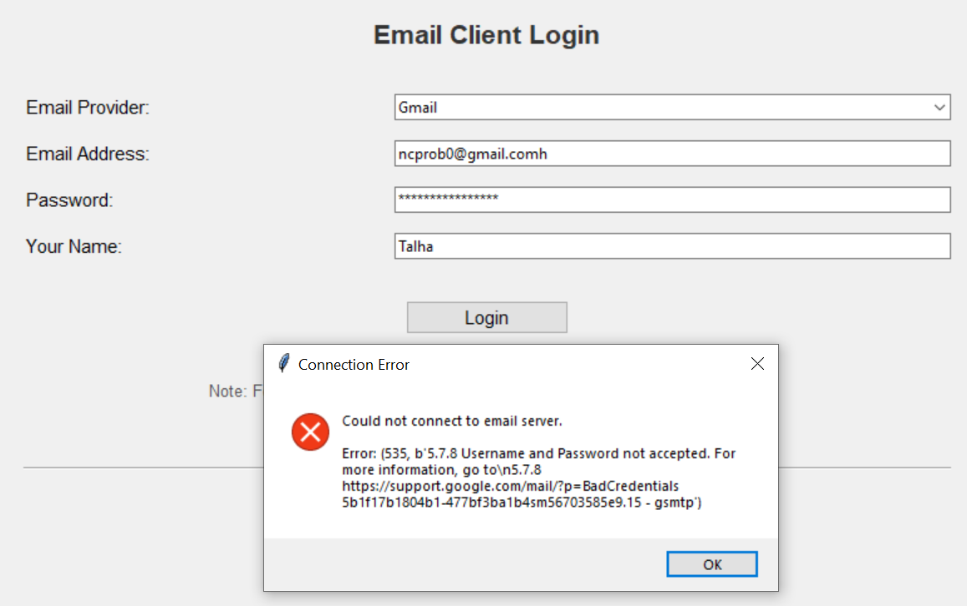
Fig 6. Invalid Email Address

- TC-01
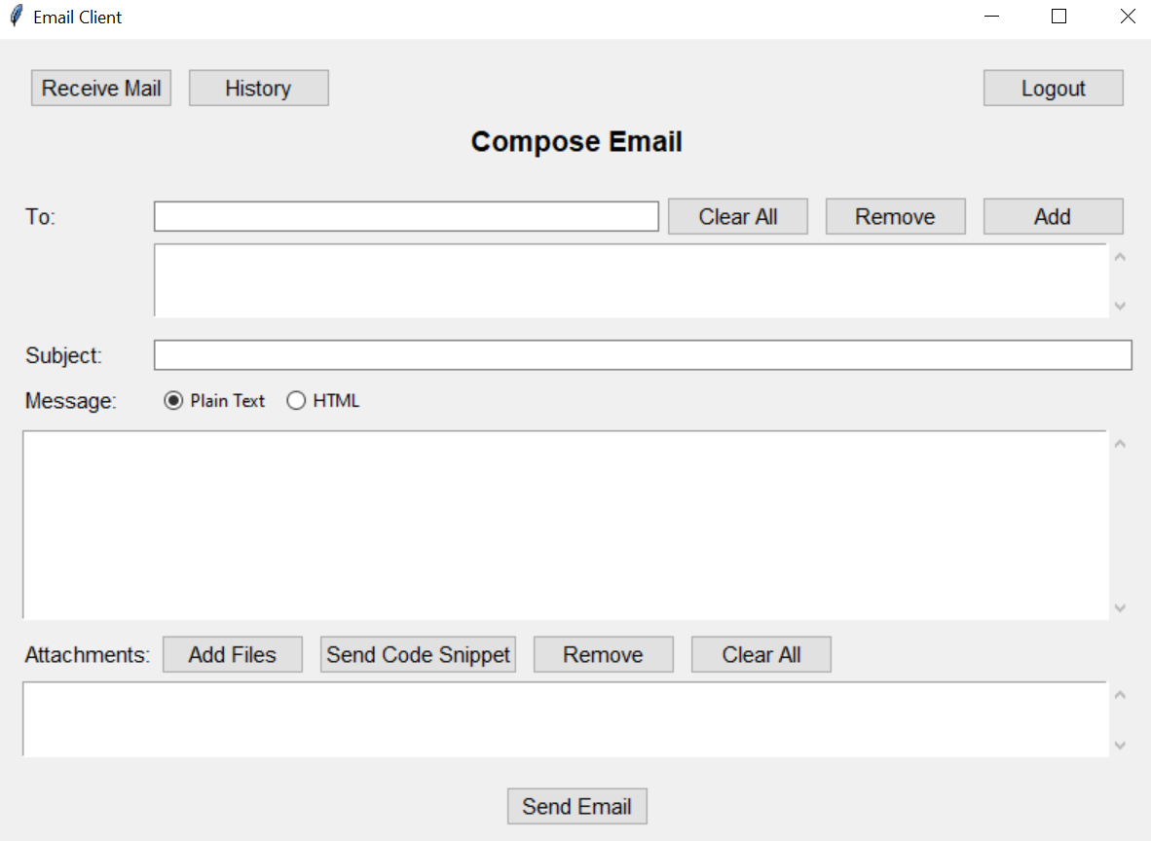
Fig 7. Successful Login

- TC-15-16-79-81-82

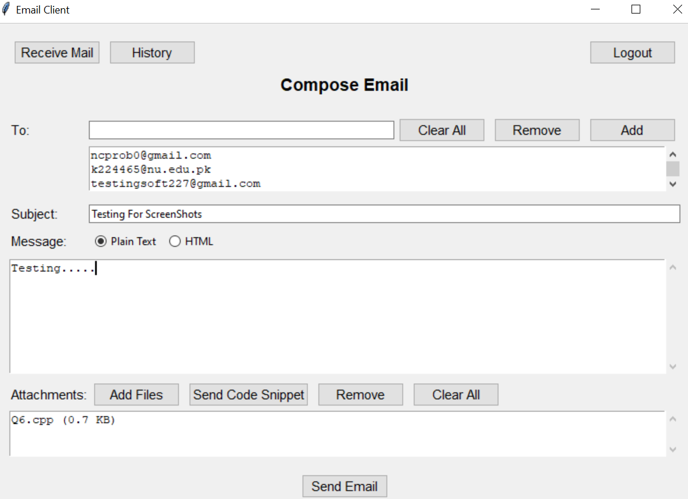
Fig 8. Multiple Test Cases

- TC-29-31-36-57-66-67

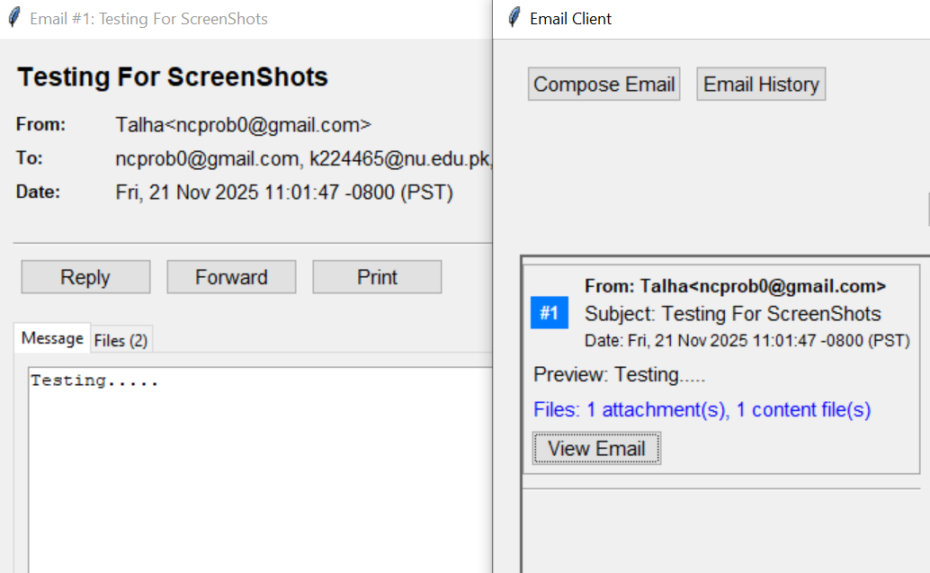
Fig 9. Multiple Test Cases when Email Received

9.2 Failed Test Cases
This section highlights test cases that failed during execution, identifying bugs and areas requiring fixes.
- TC-98
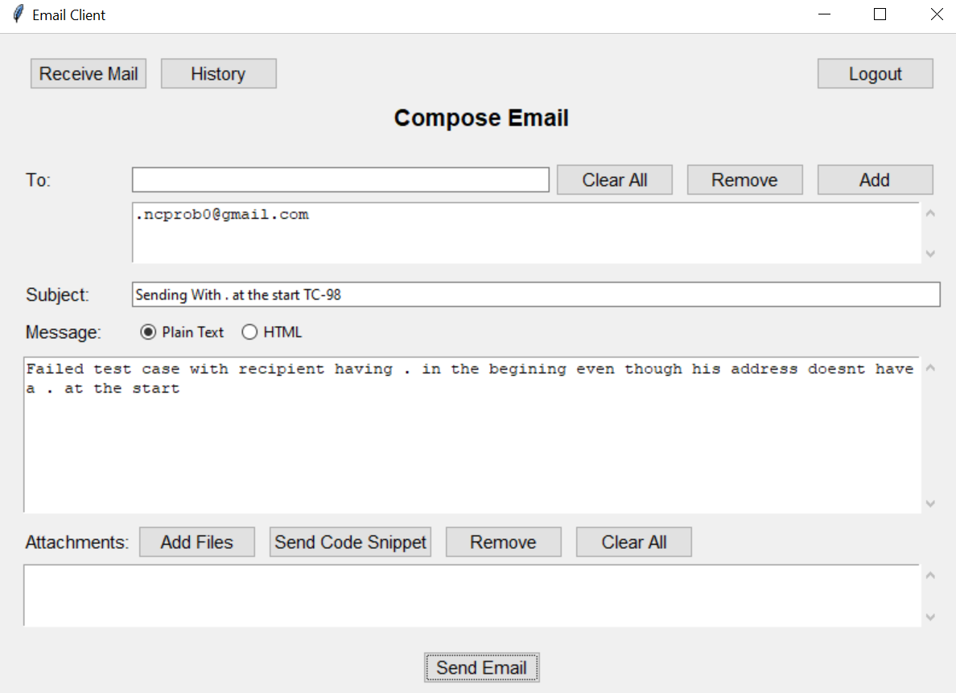
Fig 10. Sending an Email with . at the start of the Recipient

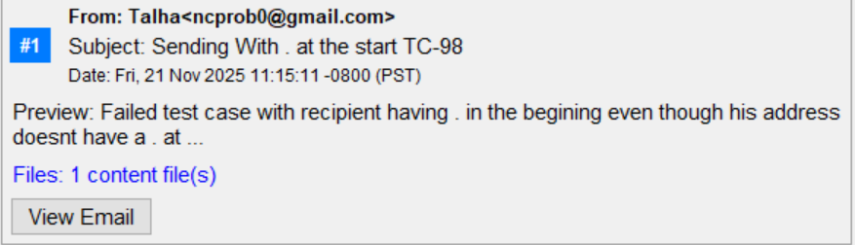
Fig 11. Receiving that Email
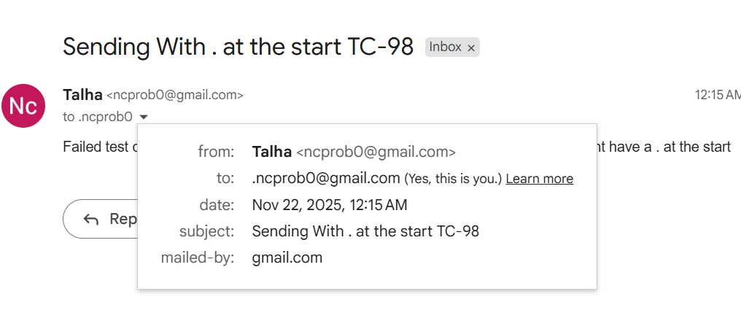
Fig 12. Google stating the address with . is actually us.
This is a special case (i) as unittest understands that the email is sent which means it is sending the email with the address of recipient plus “.” at the start. Whilst Google verifies the address is no other than the recipient.

- TC-103
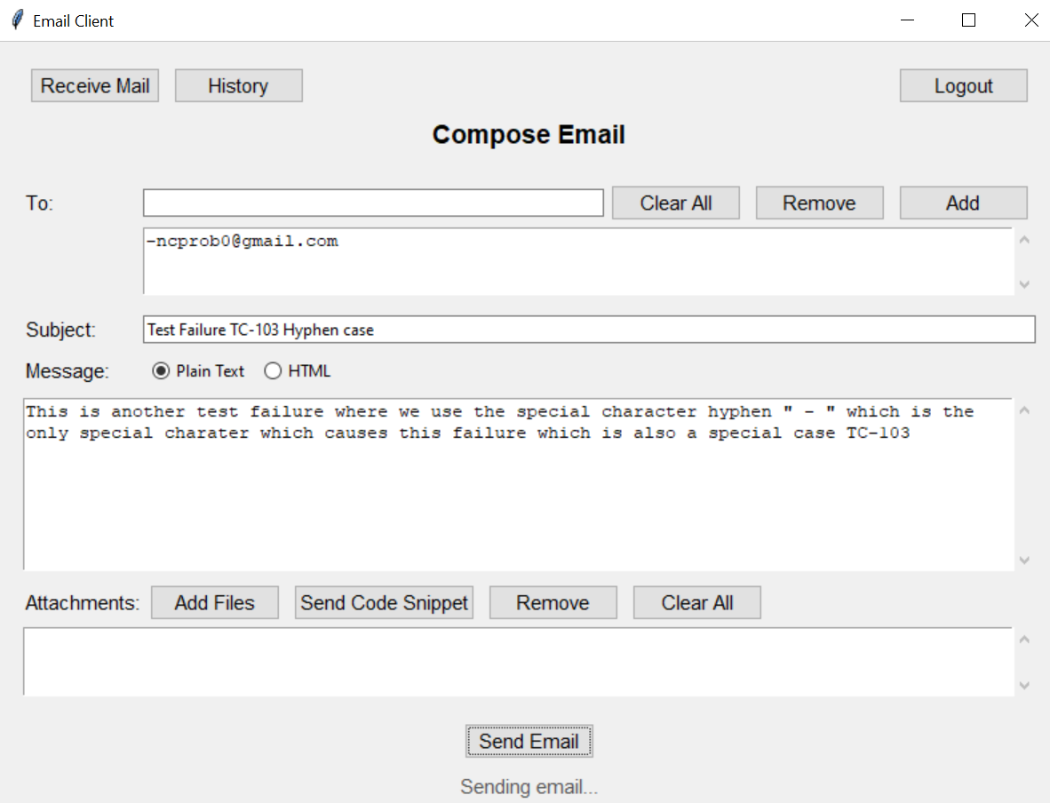
Fig 13. Sending Email with Recipient Address starting with -

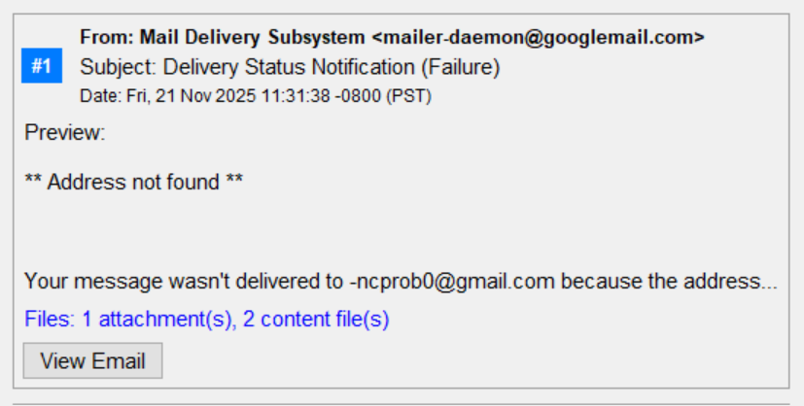
Fig 14. Receiving the email from Delivery Subsystem

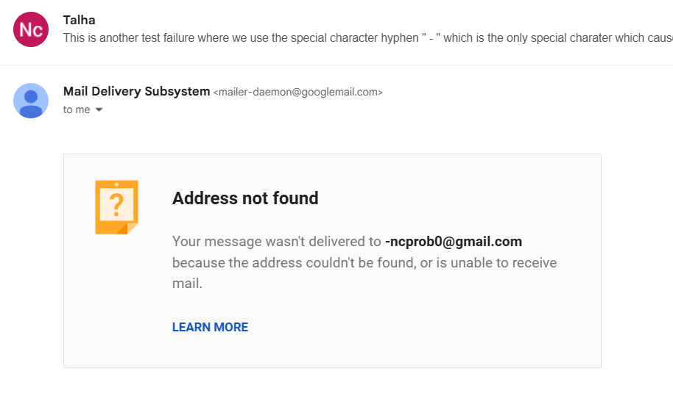
Fig 15. Delivery Subsystem confirming no recipient with such address exist

This is another special case (ii) because here the email address starts with a hyphen which is one extra character to the original address but the email is sent hence the unittest detects this behavior and marks it as fail as it does not know from the server side that the email address does not exist as stated by the Mail Delivery Subsystem.

9.3 Test Execution Summary
Overall Statistics:

Metric | Value
Total Test Cases | 119
Passed | 117
Failed | 2
Pass Rate | 98.32%
Fig 16. Statistics Table

10. Testing Metrics and Analysis

10.1 Test Distribution
Test Distribution by Serverity :

Severity | Count | Percentage
Critical | 9 | 7.56%
High | 45 | 37.82%
Medium | 57 | 47.90%
Low | 8 | 6.72%
Fig 17. Total Tests as per Severity

Test Distribution and Coverage by Category :

Category | Test Cases | Pass Rate
Email Validation | 6 | 100% (6/6)
Database Operations | 8 | 100% (8/8)
Email Sending | 6 | 100% (6/6)
Email Receiving | 9 | 100% (9/9)
Attachments | 7 | 100% (7/7)
Integration Tests | 4 | 100% (4/4)
Security Tests | 6 | 100% (6/6)
Performance Tests | 4 | 100% (4/4)
Content Types | 5 | 100% (5/5)
Date/Time Operations | 3 | 100% (3/3)
Edge Cases | 7 | 100% (7/7)
GUI Features | 25 | 100% (25/25)
Real-World Validation | 10 | 100% (10/10)
Advanced Email Validation | 10 | 80% (8/10)
Print Functionality | 9 | 100% (9/9)
Fig 18. Total Tests as per Modules & Coverage

Test Distribution by Type :

Test Type | Count | Percentage
Positive | 54 | 45.38%
Negative | 19 | 15.97%
Boundary | 15 | 12.61%
Security | 9 | 7.56%
Verification | 10 | 8.40%
Validation | 8 | 6.72%
Performance | 4 | 3.36%
Fig 19. Total Tests as per Type

10.2 Defect Metrics
Defects by Severity:

Severity | Count
Critical | 0
High | 2
Medium | 0
Low | 0
Fig 20. Total Defect as per Severity

Defects by Category:

Category | Defects
Email Validation | 0
Database Operations | 0
Email Sending | 0
Email Receiving | 0
Attachments | 0
Integration Tests | 0
Security Tests | 0
Performance Tests | 0
Content Types | 0
Date/Time Operations | 0
Edge Cases | 0
GUI Features | 0
Real-World Validation | 0
Advanced Email Validation | 2
Print Functionality | 0
Fig 21. Total Defects as per Modules
10.3 Test Execution Metrics
Execution Time Analysis:

Response Statistics | Time
Total | 12.54 s
Average | 0.105 s
Fig 22. Time Measurements

10.4 Quality Metrics

Metric | Value
Total Test Cases | 119
Successful | 117
Failed | 2
Success Rate | 98.32%
Failure Rate | 1.68%
Time Taken | 12.54 s
Line of Code | 2900
DRE | 100%
MTTD | 6.27 s
DD | 0.69 KLOC
TCDD | 1.68%
Fig 23. Measurements

11. Conclusion
The comprehensive testing effort for the SMTP Email Client application has demonstrated exceptional quality and reliability, with 117 out of 119 test cases passing successfully, achieving an impressive pass rate of 98.32%. This extensive test suite, comprising 119 test cases across 15 different categories, validates the robustness of the application's core functionality, security measures, and user interface features.

11.1 Overall Assessment
The application has proven to be production-ready with strong performance across all critical areas. All security tests passed without exception, confirming that the system effectively prevents SQL injection, XSS attacks, and path traversal vulnerabilities. Database operations function flawlessly with 100% reliability, and the email sending/receiving mechanisms handle various content types, attachments, and edge cases appropriately. The user interface features, including reply, forward, print, and code snippet handling, all operate as designed.
Performance testing revealed that the system efficiently manages large-scale operations, including handling 100 recipients per email, processing 10,000-character email bodies, and managing 50 simultaneous attachments without degradation. The application's ability to support 17+ programming languages for code snippets and properly handle unicode characters demonstrates its versatility and modern design approach.

11.2 Analysis of Failed Test Cases
Only two test cases failed during execution, both related to email validation edge cases that involve addresses starting with special characters. It is important to note that while these test cases failed at the validation level, the actual behavior observed when interacting with real SMTP servers provides valuable insights:
Email Addresses Starting with a Dot (.user@example.com):
The application's validation regex accepts email addresses beginning with a dot, which technically violates RFC 5322 standards. However, in real-world testing, when attempting to send an email to such an address (e.g., ".ncprob0@gmail.com"), Gmail's system interprets this as the sender's own address and treats it as a self-send rather than rejecting it outright. While this represents a validation oversight, the practical impact is minimal as the email system itself provides a safeguard.
Email Addresses Starting with a Hyphen (-user@example.com):
Similar to the dot scenario, the validation allows hyphens at the start of email addresses. In practice, when sending to an address like "-ncprob0@gmail.com", the email delivery system properly handles this by rejecting the email with an appropriate error message: "Address not found - Your message wasn't delivered to -ncprob0@gmail.com because the address couldn't be found, or is unable to receive mail" from the Email Delivery Subsystem. This demonstrates that while the client-side validation has a gap, the server-side SMTP infrastructure acts as a secondary validation layer.
These failures highlight an important distinction between client-side validation and server-side behavior. The current regex pattern prioritizes broad acceptance over strict RFC compliance, which allows some technically invalid formats to pass through to the SMTP server for final validation.

To get access to the project files contact munirtalha613@gmail.com as the project contains some private information which can't be uploaded without some changes

